CS560 Knowledge Discovery and Management

Jan. 21 (T), 2013

**By**

**Ponnam Balakrishna**

**16177831(BP8G6)**

1. **ER Diagram and Class Diagram Using Visio**

**1) ER Diagram**: Suppose we wish to keep a genealogy. We shall have one entity set, Person. The information we wish to record about persons includes their name (an attribute) and the following relationships: mother, father, and children. Give an E/R diagram involving the Person entity set and all the relationships in which it is involved. Include relationships for mother, father, and children. Extend it with additional relationships such as husband and wife. Do not forget to indicate roles when an entity set is used more than once in a relationship.

**Sol:**



The above screen shows the ER diagram of a person family. Considering a Person a person has both Parents and Childrens.The parents can be Mother and Father, Chidren can be son and Daughter. Wife and Husband Relation is maintained between Father and Mother, Brother and Sister relation is maintained between son and daughter. Between the children and Parents of a Person the relationship is Grandparents/Grandchildren.

**2) Class Diagram**: For the given domain (i.e., Family), define UML Class Diagram that specifies classes and their relationships with specific relationships such as inheritance, aggregation, composition, dependence, association, etc.



The above Class Diagram represents the Family Structure with relationships.Considering every person in the family is a family member.It also shows different levels of structure with inheritance aggregation,composition,… and also shows the relationship between different entities.The level of each structure in the family denotes inheritance.Each person can be treated as a Family member in the family.

**2)Create a Github Account**

Go to github.com and Sign up.the screen shot shows the Login page of the gitbub

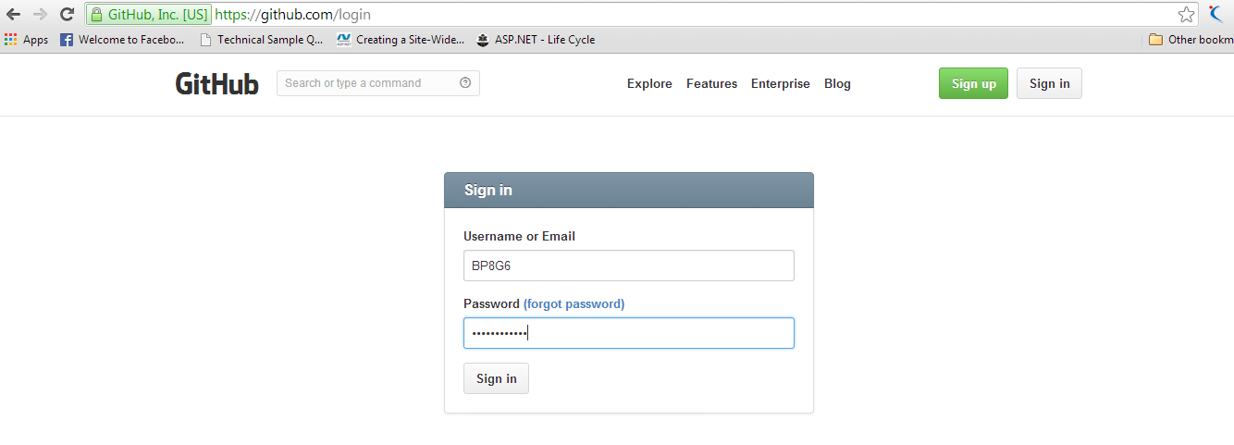

Set the Organisation name and the Organisation Plan for the Github account

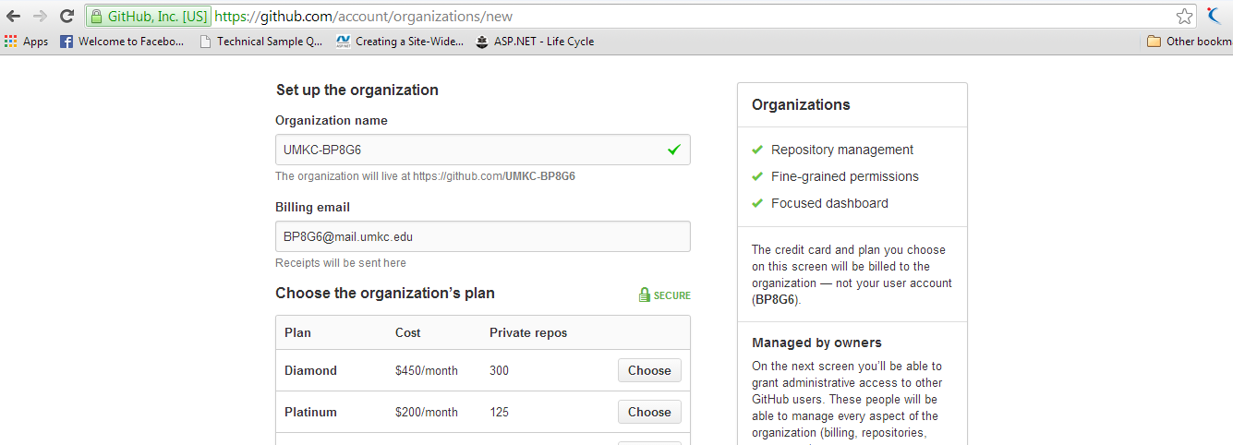

**3)Create a Scrumdo Account**

Go to Scrumdo.com and Signup for the account and get login.Here is the Screenshot for Login

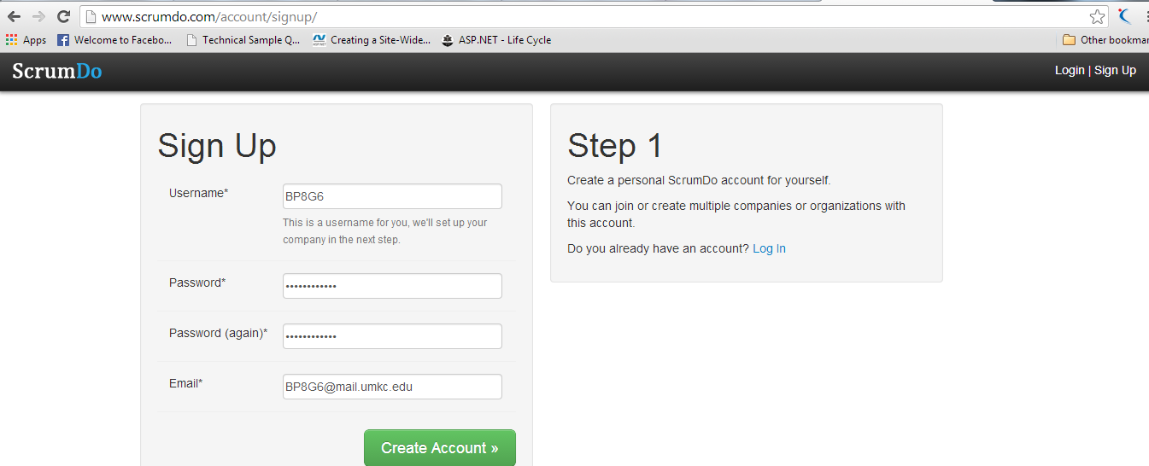

Create an Organization in the Srumdo

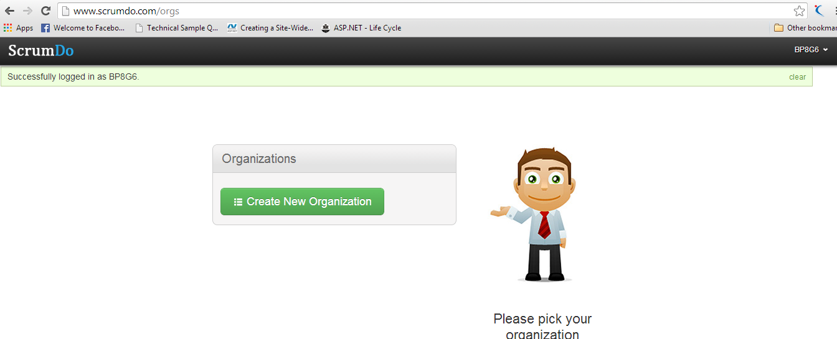

Here is the Screen Shot Naming the Organization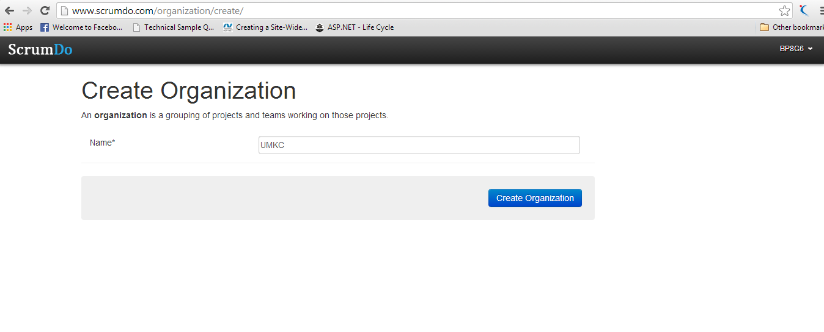

Choose the Subscription Plan for the Organization

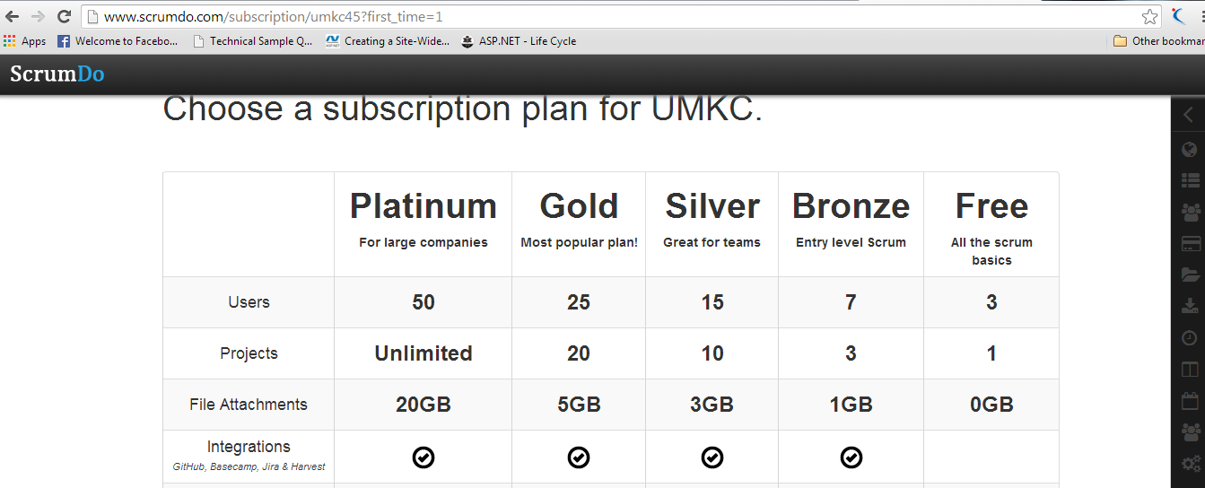

Screenshot to add a Story

Add a Story, Details of the story and tag the users who are working and assign number of hours required, Difficulty rate ,Category to which it belongs if category is not added add a new category and select the Iteration.

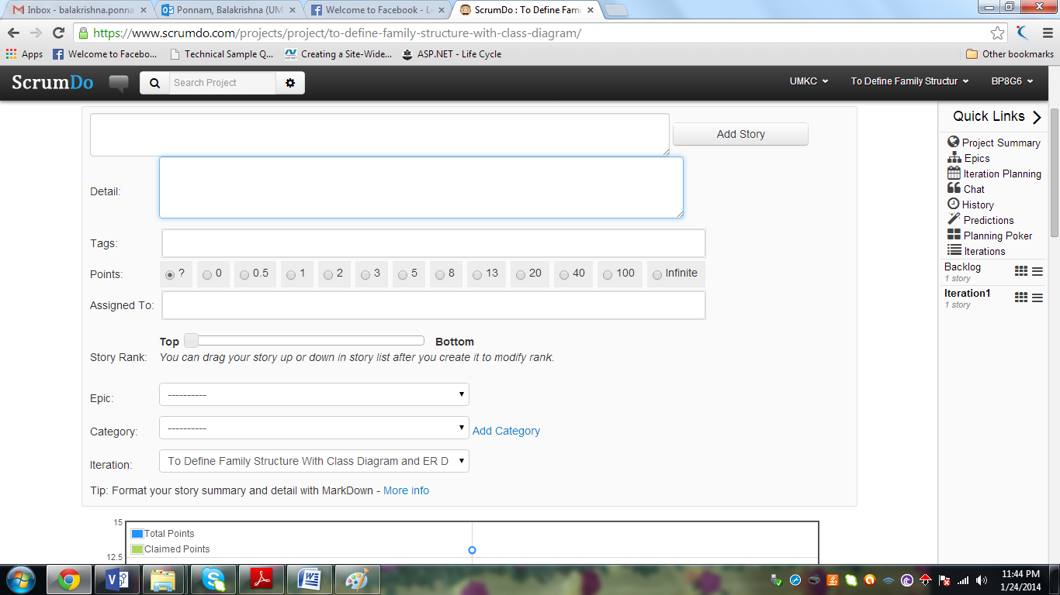

Creating the New Iteration

Create the new Iteration and assign the Start Date and the End Date of the Particular Iteration

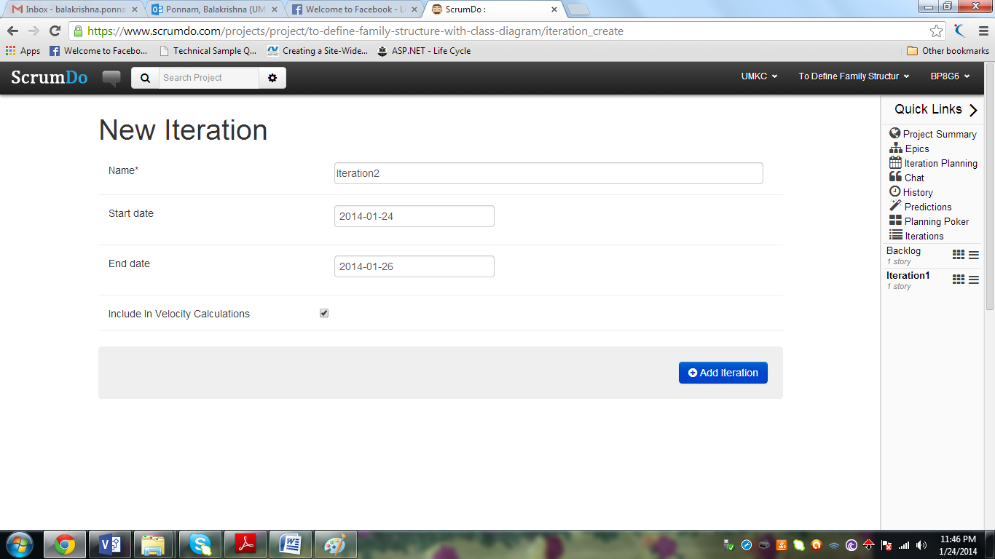

To Do in Backlog

Job To do in the to do list. This is the Screenshot of the Todo .Todo Indicates the Pending jobs to be done

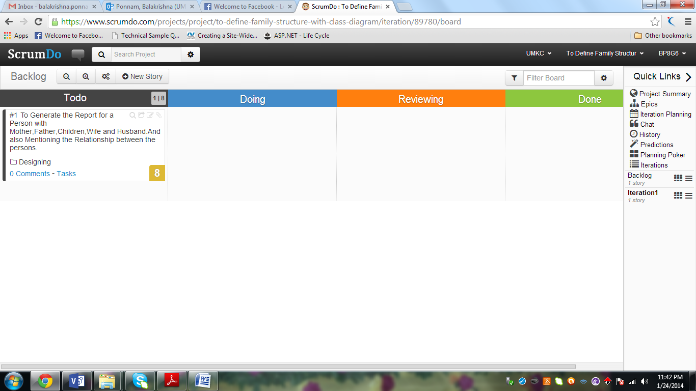

The below Screen Indicates the graph of the Todo things in Backlog

The graph is drawn between Days and the ongoing process(Todo,Doing,Reviewing,Done)

This Graph is shown in Iteration1

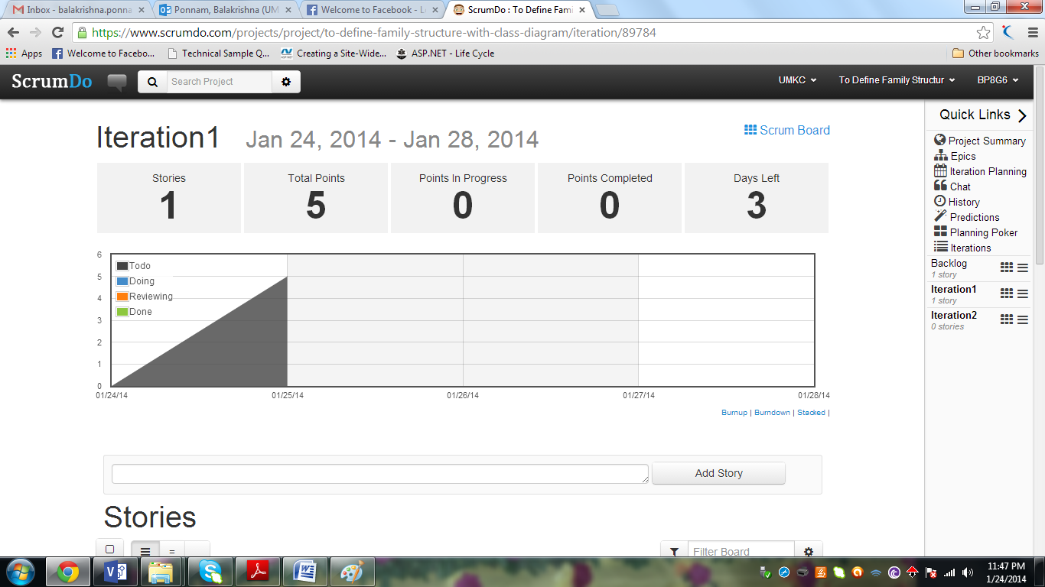

This Graph is Shown in iteration2

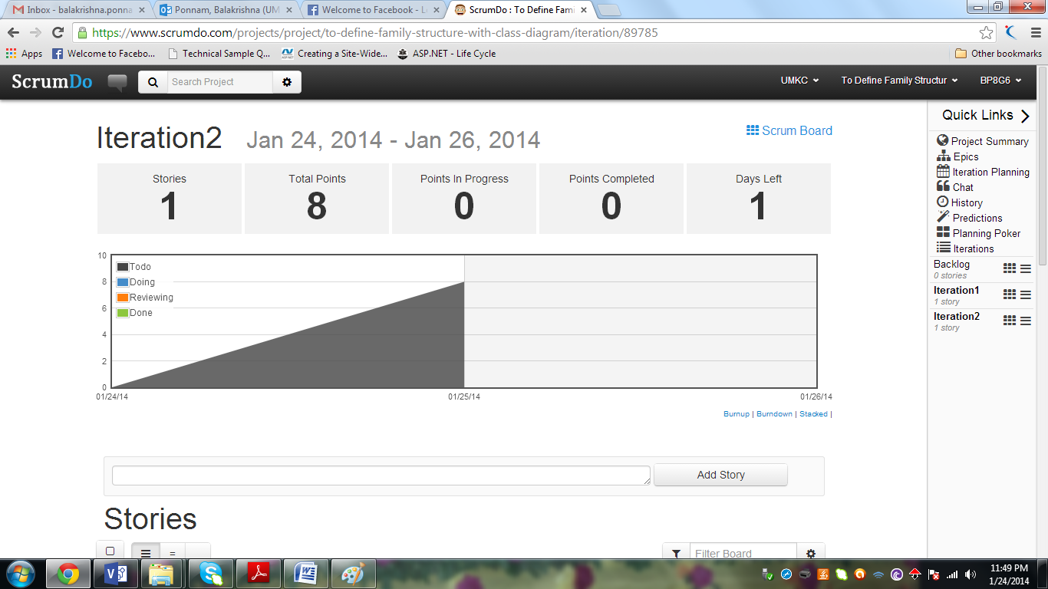

This Screen Shown the Total points between the dates and the process Done between the dates.

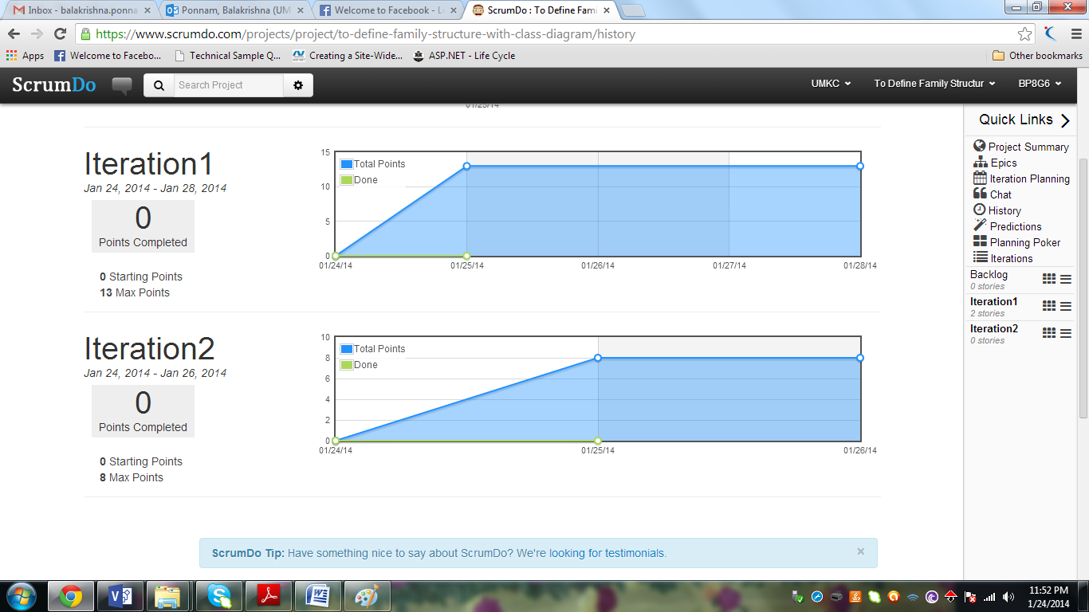

This Screen shows Graph between the Days and Pending jobs(i.e Todo,Doing,Reviewing,Done)

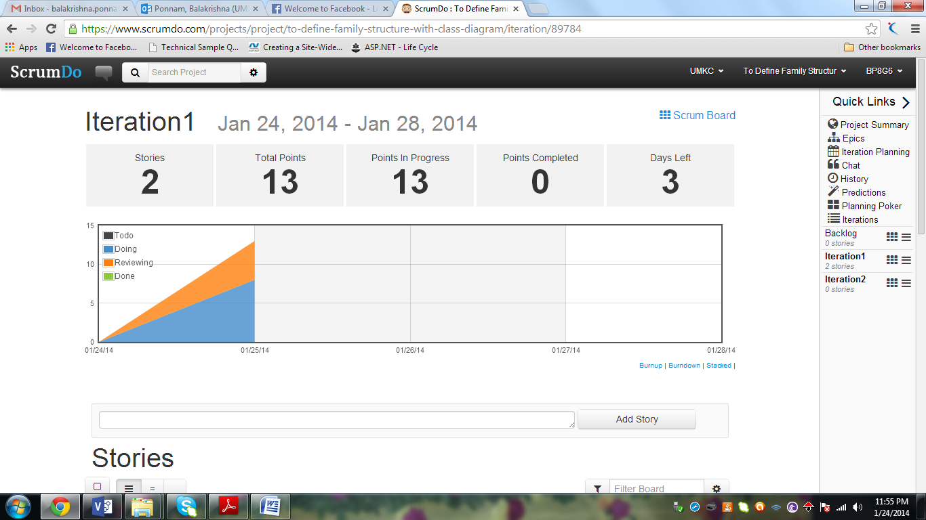

The Below Screen describes one story has be completed(done) and one story is Reviewing

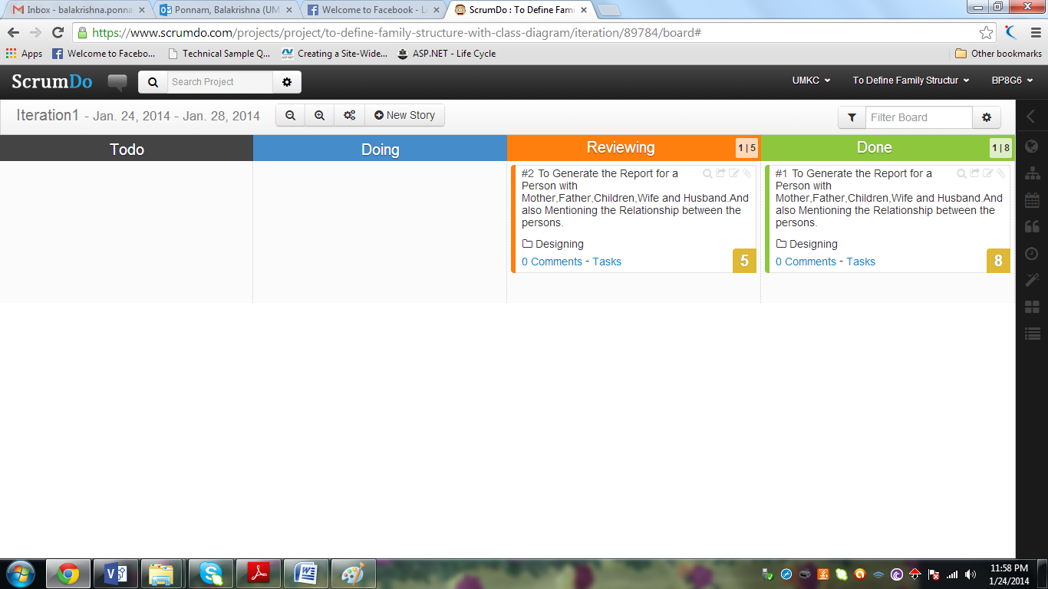

This Screen Shows that all the Stories are done

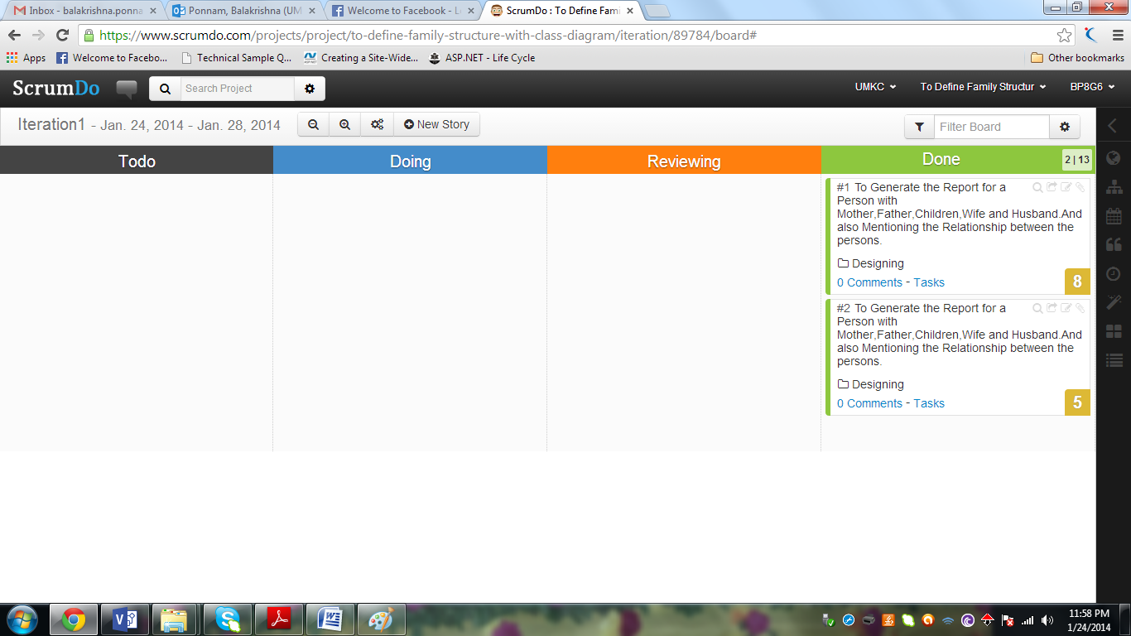

The below Graph describes all the jobs are done and the screen indicates the total points, Points in progress ,points completed and number of days left.

